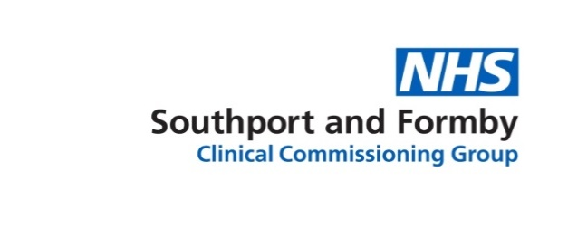
Interested in getting involved in local healthcare?
Patient Participation Group event
We’re looking for local residents to join their GP practice’s Patient Participation Group to learn more about healthcare services and to support their surgery. Come along to our event to find out more and discuss how you can get involved.
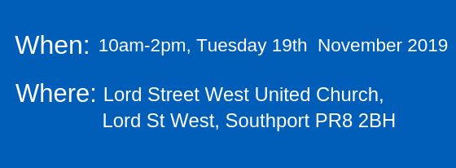

What to expect at the event:
- Find out what a Patient Participation Group (PPG) does, what being a member involves and hear from current PPG members
- Learn about new developments and services at your GP practice and in the community
- Meet and chat to a variety of healthcare professionals working across Sefton at our health and wellbeing marketplace
Refreshments and a light lunch will be provided
To register please call us on 01704 395785 or email southportandformby.ccg@nhs.net

